Fix-it (rounds 1-3)

8 feet

8 feet

8 feet

18 feet

10 feet

8 feet

Perfect word (round 1)

Playground

120 feet

Athletic Field

360 feet

120 feet

160 feet

Perfect word (round 2)

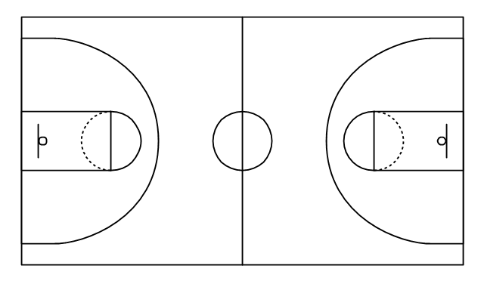

Basketball court

40 feet

40 feet

84 feet

50 feet

Courtyard

Use these formulas to find the perimeter of the playground and athletic field:<br>Perimeter of a square: P = 4S<br>

Perimeter of a rectangle: P = 2L + 2W <br><br>Look at the drawing to find the values for S, L, and W<br><br>To find the total perimeter of both areas, add the playground perimeter to the athletic field area and subtract the distance of their shared side.

To find the total perimeter of both areas, add the basketball court's perimeter to the courtyard's perimeter. You do not need to subtract anything because the areas don't share a side.

Perfect word (round 3)

6 feet

6 feet

6 feet

6 feet

15 feet